**Software Requirement Specification for BIT-Placement Candidates Details Portal**

|  |  |
| --- | --- |
| **Name** | Padmavathi S J |
| **Roll no** | 7376221CS253 |
| **Seat no** | 69 |
| **Project ID** | 29 |
| **Problem Statement** | BIT-Placement Candidates Details Portal |

**1.Introduction:**

**1.1 Purpose:**

The purpose of the "Interview Candidates Details Portal" is to streamline the management of hired candidates by providing a centralized platform for accessing and maintaining essential candidate information. This app facilitates easy retrieval of details such as educational background, contact information, interview schedules, and selection status. By organizing candidate data efficiently, the application enhances the hiring process, improves decision-making, and ensures effective communication between stakeholders involved in candidate management.

**1.2 Scope of Project:**

The "Interview Candidates Details Portal" facilitates candidate registration, job posting, interview scheduling, communication, document management, feedback collection, and analytics. It streamlines the hiring process by providing a centralized platform for managing candidate information, interactions, and evaluation, enhancing efficiency and organization in recruitment efforts.

**User Authentication and Profile Creation:** Candidates register and create profiles detailing their qualifications and experiences.

**Interview Scheduling:** Candidates and interviewers can schedule interviews, with automated reminders.

**Communication Features:** Internal messaging system for correspondence between candidates, interviewers, and hiring managers.

**Document Management:** Uploading and sharing of resumes, cover letters, and other relevant documents.

**Feedback and Evaluation:** Mechanism for interviewers to provide feedback on candidates, with tracking of candidate progress.

**Analytics and Reporting:** Dashboard for administrators to monitor platform usage, interview statistics, and candidate demographics.

**Integration with HR Systems:** Seamless integration with existing HR systems for candidate data synchronization and workflow management.

**2. System Overview:**

**2.1 Users:**

**1. Students:**

Candidates can enter personal details, educational background, and upload resumes. They track application status, schedule interviews, and review interaction history.

**2. Admins:**

Administrators review candidate submissions, manage interview schedules, and oversee selection. They can approve or reject applications, schedule meetings, and access analytical dashboards for recruitment oversight.

**2.2 Features:**

**1. User Authentication and Profile Management:**

* Candidates can register or log in to their accounts.
* Profile management includes updating personal and professional information.

**2. Candidate Details Submission:**

* Candidates input details such as name, contact information, educational background, and professional experience.
* They can upload resumes and cover letters.

**3. Application Submission:**

* Candidates can submit applications for job opportunities.
* Required details may include job title, company, desired salary, and cover letter attachments.

**4. Application Status Tracking:**

* Candidates can track the status of their applications.
* They can view past activities and updates related to their applications.

**5. Interview Scheduling:**

* Candidates can request or schedule interviews through the portal.
* Automated reminders for upcoming interviews may be included.

**6. Admin Dashboard:**

* Admins have access to a dashboard displaying candidate details, application statuses, and interview schedules.
* They can view and manage candidate profiles and applications.

**7. Communication Features:**

* Internal messaging system facilitates communication between candidates and admins.
* Enables correspondence regarding application status, interview scheduling, and feedback.

**8. Document Management:**

* Candidates can upload and manage documents such as resumes, certificates, and references.
* Admins can access and review submitted documents for application evaluation.

**9. Feedback and Evaluation:**

* Admins can provide feedback on candidates' applications and interviews.
* Candidates can view feedback and evaluation results.

**10. Analytics and Reporting:**

* Admins have access to analytics and reports on candidate demographics, application trends, and interview outcomes.
* Insights aid in refining recruitment strategies and improving the candidate experience.

**User’s Interface**

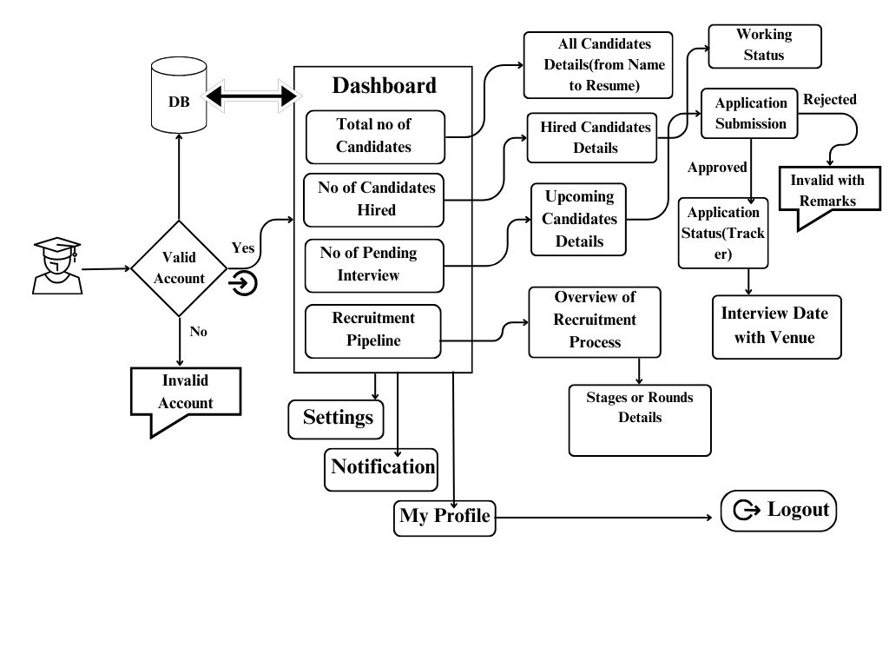

**Admin’s Interface**

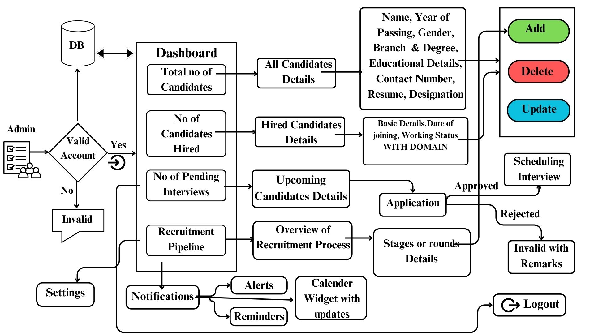

**3. Functional Requirements:**

**1. User Authentication and Authorization:**

* Candidates, and administrators should be able to register and log in with their respective credentials.
* Users should receive email confirmation upon registration.
* Different roles such as candidate, and admin should have distinct permissions and access rights.

**2. Candidate Profile Management:**

* Candidates should be able to create, update, and manage their profiles.

**Profile details should include:**

* Full name
* Gender
* Year of passing
* Branch and Degree
* Educational details
* Contact number
* Resume/CV upload
* Photo
* Address

**3. Job Application Tracking:**

* Track the status of job applications for each candidate.

**Include details such as:**

* Designation applied for
* Date of application
* Selection status (selected, rejected, pending)
* Date of Interview

**4. Selection Status:**

* Display the selection status of candidates, indicating whether they have been hired or not.
* Record the date of joining for hired candidates.

**5. Appointment Scheduling:**

* Candidates with approved job offers should be able to request appointments after a certain period (e.g., 30 days) from the date of joining.
* Allow candidates to schedule appointments for meetings or orientation sessions.

**6. Admin Dashboard:**

* Admins should have access to a dashboard to oversee candidate profiles, job applications, selection status, and appointments.
* Admins should be able to view and update candidate details, as well as mark candidates as hired or rejected.
* Ability to filter and search candidate profiles based on various criteria.

**7. Analytics and Reporting:**

* Provide analytics on candidate demographics, selection trends, and recruitment metrics.
* Generate reports on candidate activity, job application status, and hiring statistics.

**8. Communication Features:**

* Internal messaging system for communication between candidates, recruiters, and admins.
* Notifications to candidates regarding job application status updates, interview schedules, and selection decisions.

**9. Privacy Settings:**

* Candidates should be able to manage their profile privacy settings to control what information is visible to others.

**10. Data Security and Compliance:**

* Implement robust security measures to protect candidate data.
* Ensure compliance with data protection regulations (e.g., GDPR, CCPA) and maintain candidate privacy.

**4. Non Functional Requirements:**

**1. Performance:**

* The user experience should be seamless and effective, with fast page loads and timely response to user inputs.
* There should be no significant delay during critical tasks such as logging in, accessing candidate profiles, and updating candidate details.
* The portal should maintain optimal performance even during high usage periods.

**2. Security:**

* **Data Encryption:** User data, including passwords, should be securely encrypted to prevent unauthorized access.
* **Secure Authentication:** Secure authentication methods like HTTPS should be employed to protect user login credentials from interception.
* **Role-Based Access Control:** Access to sensitive functionalities and data should be controlled based on user roles to prevent unauthorized access.
* **Frequent Security Audits:** Regular security audits and vulnerability assessments should be conducted to detect and mitigate any security threats.
* **Compliance with Data Protection Regulations:** The portal must comply with all applicable data protection laws, ensuring the security and privacy of user data.

**3. Usability:**

* **Simple Navigation and Consistent Design Elements:** The user interface should be easy to navigate and intuitive, with consistent design elements throughout the portal.
* **Responsive Design:** The portal should be responsive and accessible across various devices and screen sizes, including smartphones, tablets, and PCs.
* **Clear Feedback:** Users should receive clear feedback when performing actions such as submitting forms, receiving error messages, or receiving status updates.
* **Help and Support Resources:** The portal should provide help documentation, FAQs, and support contact details to assist users in navigating and using the platform efficiently.

**4. Reliability:**

* **High Availability:** The portal must be highly available and accessible to users with minimal downtime, ensuring continuous access to essential features and functionalities.
* **Error Handling:** The portal should handle errors gracefully, providing informative error messages and recovering from unforeseen faults seamlessly.
* **Data Integrity:** Strong data validation and error checking procedures should be in place to prevent data loss or corruption, ensuring the integrity of user data.

**5. Compatibility:**

* **Browser Compatibility:** The portal should be compatible with modern web browsers such as Google Chrome, Mozilla Firefox, Microsoft Edge, and Safari.
* **Device Compatibility:** The portal should work seamlessly on a variety of devices and operating systems, including Windows, macOS, iOS, and Android.
* **Integration Compatibility:** The portal should be compatible with third-party services and APIs, facilitating easy integration with external systems such as email services for notifications and messaging.

**Backend:**

1. **Student entity(Login):**

|  |  |
| --- | --- |
| name | String |
| email | String |
| password | Hash code |
| Roll no | String |

1. **Candidates Details:**

|  |  |
| --- | --- |
| Name | String(VARCHAR) |
| Year of passing | YEAR or INT |
| Gender | CHAR |
| Branch & Degree | String(VARCHAR) |
| Contact Number | String(VARCHAR) |
| Designation | String(VARCHAR) |
| Date of Interview | Date or DateTime |
| Selection Status | Boolean or Enum |
| Date of Joining | Date or DateTime |
| Working Status | Boolean or Enum |
| Address | String(VARCHAR) |

1. **Educational Details:**

|  |  |
| --- | --- |
| Institute Name | String(VARCHAR) |
| Degree | String(VARCHAR) |
| Field of Study | String(VARCHAR) |
| Year of Graduation | INT |
| Grade Point Average(GPA) | Decimal or Float |
| Honors/Awards | String(VARCHAR) |
| Certifications | String(VARCHAR) |

**Stack:**

|  |  |
| --- | --- |
| Front End | React js, |
| Back End | Java with Spring Boot |
| Database | MySQL |
| API | REST Ful API |

**5. Prototype of the Project:**

**1.Login Page:**

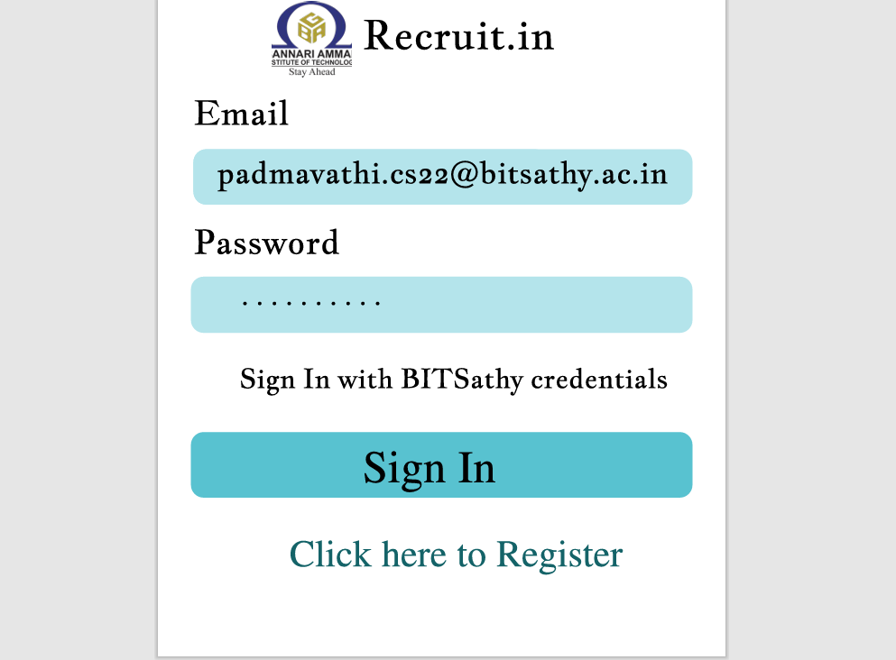

**2.Register Page:**

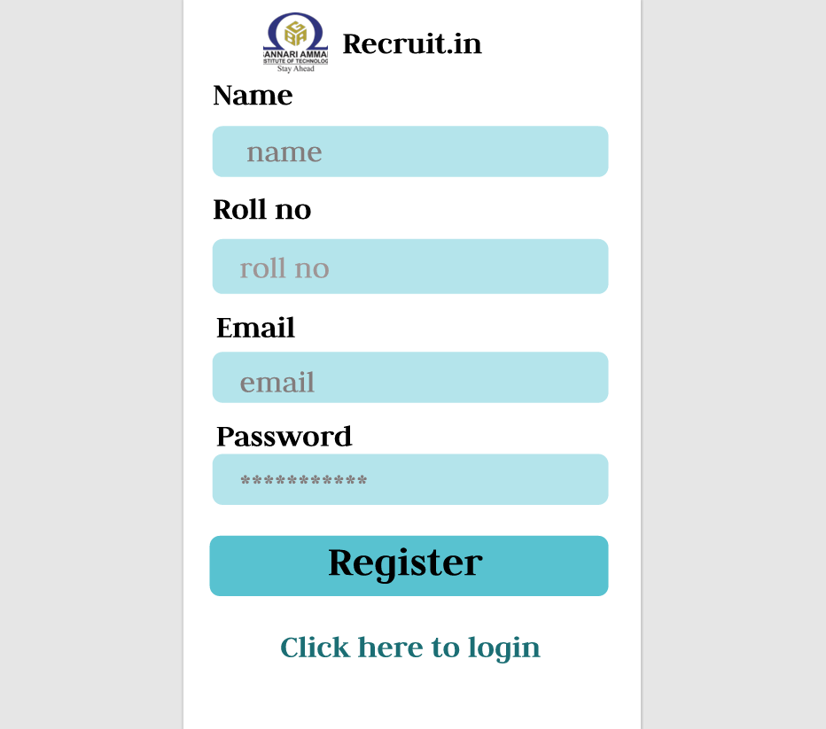

**3.Dashboard view:**

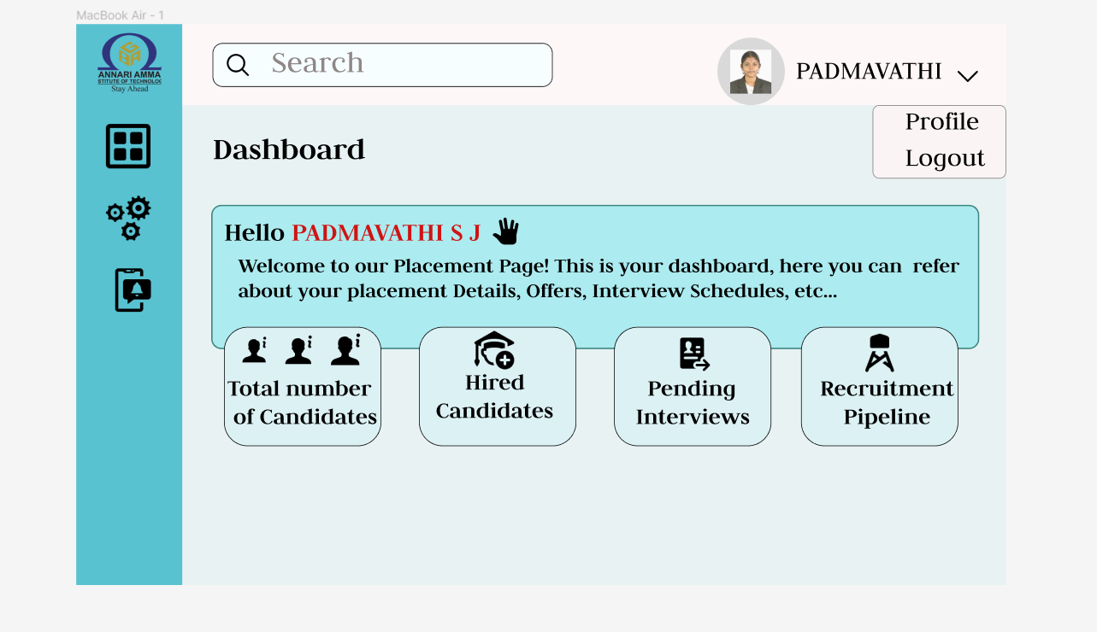

**4.Candidates Details Page:**

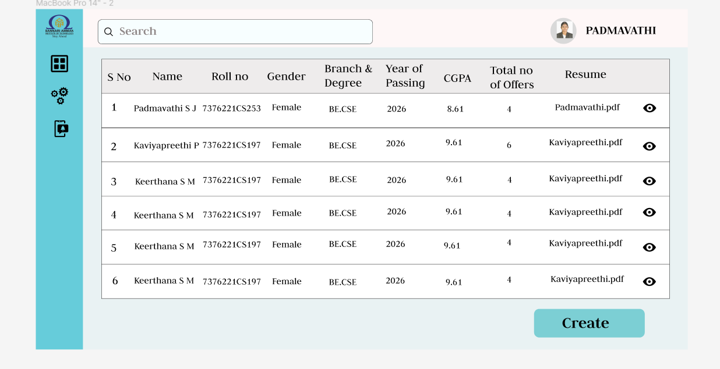

**5.Add Candidate Details Page:**

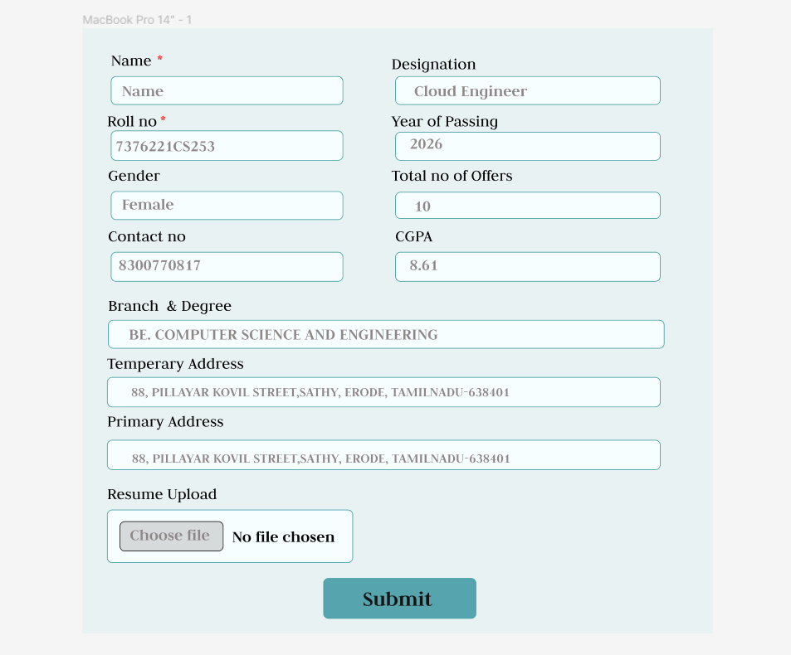

**6.Dashboard view:**

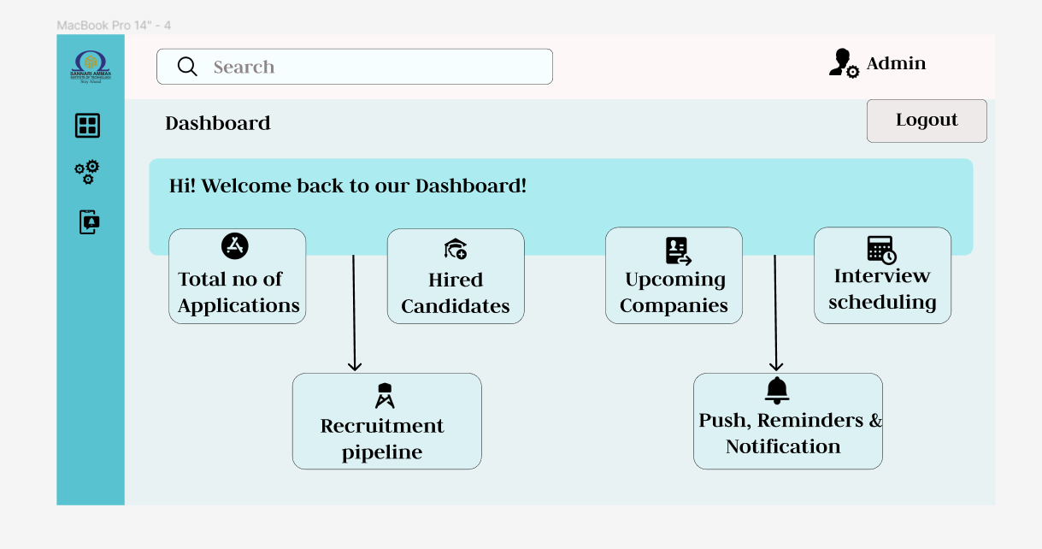

**7.Application Status View:**

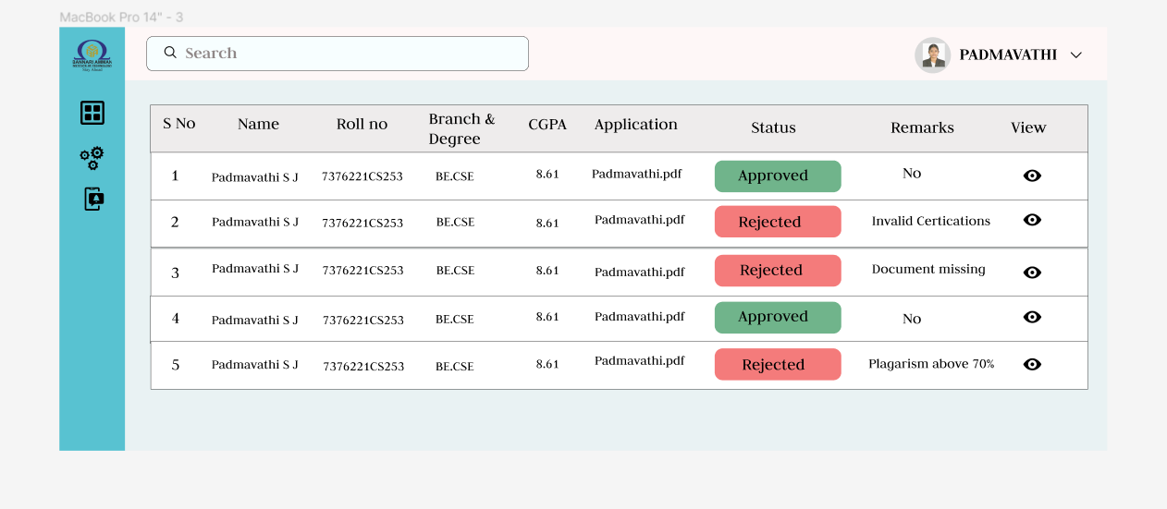

**8.Dashboard overview:**

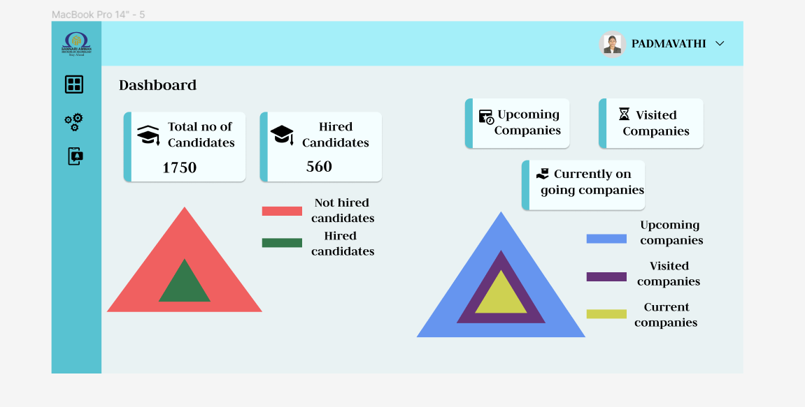

**9.Recruitment Pipeline:**

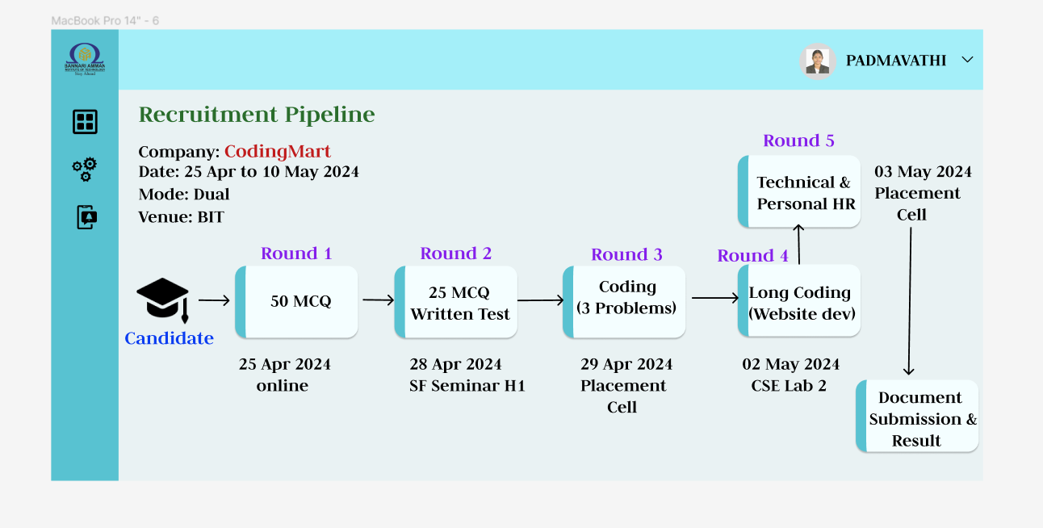

**6. Conclusion:**

This is like a digital filing cabinet for keeping track of job applicants. It stores important info like their personal details, education, interview history, and whether they got hired. Using a smart system, it makes sure all the data stays accurate and easy to find. This portal makes the hiring process smoother by helping recruiters stay organized and keeping everything in one place. It's user-friendly, so both recruiters and applicants can easily navigate it. Overall, it's a handy tool that helps make hiring decisions faster and more efficient.